**Project Planning Phase**

**Project Planning Template (Product Backlog, Sprint Planning, Stories, Story points)**

|  |  |
| --- | --- |
| Date | 31 OCTOBER 2022 |
| Team ID | PNT2022TMID09881 |
| Project Name | A Novel Method for Handwritten Digit Recognition System |
| Maximum Marks | 8 Marks |

**Product Backlog, Sprint Schedule, and Estimation (4 Marks)**

|  |  |  |  |  |  |  |
| --- | --- | --- | --- | --- | --- | --- |
| **Sprint** | **Functional**  **Requirement (Epic)** | **User**  **Story**  **Number** | **User Story / Task** | **Story Points Priority** | **Priority** | **Team Members** |
| Sprint-1 | Registration | USN-1 | As a user, I can register for the application by entering my email, password, and confirming my password. | 2 | High | Manoj N |
| Sprint-1 | Login | USN-2 | As a user, I can log into the application by entering email & password | 1 | High | Mahin kumaar T N |
| Sprint-2 | Upload Image of digital  document | USN-3 | As a user, I can able to input the images of digital documents to the application | 2 | Medium | Kishor kumar K T |
| Sprint-2 | Prediction | USN-4 | As a user, I can predict the word | 1 | Medium | Mathan S |

|  |  |  |  |  |  |  |
| --- | --- | --- | --- | --- | --- | --- |
| Sprint-3 | Upload Image of  Handwritten document | USN-5 | As a user, I can able to input the images of the handwritten documents or images to the application | 2 | High | Manoj N |
| Sprint-3 | Recognize text | USN-6 | As a user, I can able to choose the font of the text to be displayed | 1 | Medium | Mahin kumaar T N |
| Sprint-4 | Recognize digit | USN-7 | As a user I can able to get the recognised digit as output from the images of digital documents or images | 1 | Medium | Kishor kumar K T |
| Sprint-4 | Recognize digit | USN-8 | As a user I can able to get the recognised digit as output from the images of handwritten documents or images | 2 | High | Mathan S |

**Project Tracker, Velocity & Burndown Chart: (4 Marks)**

|  |  |  |  |  |  |  |
| --- | --- | --- | --- | --- | --- | --- |
| **Sprint** | **Total Story Points** | **Duration** | **Sprint Start Date** | **Sprint End Date (Planned)** | **Story Points Completed (as on Planned**  **End**  **Date)** | **Sprint Release Date (Actual)** |
| Sprint-1 | 2 | 6 Days | 24 Oct 2022 | 29 Oct 2022 | 2 | 29 Oct 2022 |
| Sprint-2 | 2 | 6 Days | 31 Oct 2022 | 05 Nov 2022 | 2 | 05 Nov 2022 |
| Sprint-3 | 2 | 6 Days | 07 Nov 2022 | 12 Nov 2022 | 2 | 12 Nov 2022 |
| Sprint-4 | 2 | 6 Days | 14 Nov 2022 | 19 Nov 2022 | 2 | 19 Nov 2022 |

**Velocity:**

Imagine we have a 10-day sprint duration, and the velocity of the team is 20 (points per sprint). Let’s calculate the team’s average velocity (AV) per iteration unit (story points per day)

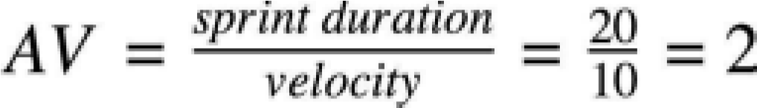

**Burndown Chart:**

A burn down chart is a graphical representation of work left to do versus time. It is often used in agile software development methodologies such as Scrum. However, burn down charts can be applied to any project containing measurable progress over time.

